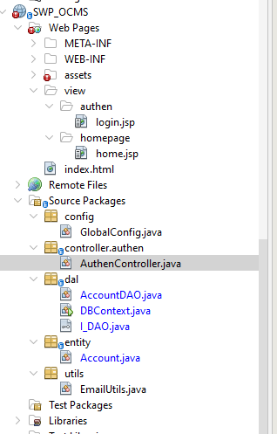

/*

* Click nbfs://nbhost/SystemFileSystem/Templates/Licenses/license-default.txt to change this license

* Click nbfs://nbhost/SystemFileSystem/Templates/Classes/Class.java to edit this template

*/

package dao;

import java.util.List;

/**

*

* @author ADMIN

* @param <T>

*/

public interface I_DAO<T> {

public List<T> findAll();

public T findById(T t);

public boolean update(T t);

public boolean delete(T t);

public int insert(T t);

}